**ABSTRACT**

WeatherCast is an innovative Android application developed using Kotlin, a modern programming language tailored for Android development. This application aims to deliver accurate and up-to-date weather forecasts while ensuring a seamless user experience. One of WeatherCast's prominent features is its ability to fetch real-time weather data from reliable sources. By accessing the latest forecasts, users can make informed decisions about their outdoor activities and travel plans. Through the utilization of GPS technology, WeatherCast offers location-based forecasts. This means that the app automatically detects the user's current location and provides personalized weather information tailored to their whereabouts. The cornerstone of WeatherCast lies in its commitment to forecast accuracy. Leveraging advanced weather APIs and algorithms, the application delivers precise forecasts encompassing essential parameters such as temperature, humidity, wind speed, and precipitation. Moreover, WeatherCast boasts an interactive user interface designed to enhance user experience. The sleek and intuitive design allows users to effortlessly navigate through weather information, making it accessible and comprehensible to users of all levels of technological proficiency. For users seeking customization options, WeatherCast offers a range of features to tailor the app to their preferences. This includes selecting preferred units of measurement, setting weather alert notifications, and saving favorite locations for quick access to their forecasts. In summary, WeatherCast stands as a comprehensive and reliable weather application for Android users. By providing accurate forecasts and intuitive functionality, it empowers users to plan their activities effectively and stay informed about changing weather conditions.

**ACKNOWLEDGEMENT**

First, we thank the almighty god for the successful completion of the project. Our sincere thanks to our chairman **Mr. S. Meganathan B.E., F.I.E.,** for his sincere endeavour in educating us in his premier institution. We would like to express our deep gratitude to our beloved Chairperson  **Dr. Thangam Meganathan Ph.D.,** for her enthusiastic motivation which inspired us a lot in completing this project and Vice Chairman **Mr. Abhay Shankar Meganathan B.E., M.S.,** for providing us with the requisite infrastructure.

We also express our sincere gratitude to our college Principal, **Dr. S. N. Murugesan M.E., PhD.,** and **Dr. P. KUMAR M.E., PhD, Director computing and information science , and Head Of Department of Computer Science and Engineering** and our project coordinator **Mrs. S. Ananthi, M.TECH** for her encouragement and guiding us throughout the project towards successful completion of this project and to our parents, friends, all facultymembers and supporting staffs for their direct and indirect involvement in successful completion of the project for their encouragement and support.

**NITHIN PRANAV  
NITHISH KUMAAR**

**PRADEEP S**

**TABLE OF CONTENTS**

|  |  |  |
| --- | --- | --- |
| **Chapter No.** | **Title** | **Page No.** |
|  | **ABSTRACT LIST OF TABLES**  **LIST OF FIGURES**  **LIST OF SYMBOLS** | **1** |
| **1** | **INTRODUCTION**   * 1. PROBLEM STATEMENT   2. SCOPE OF THE WORK   3. AIM AND OBJECTIVE OF THE PROJECT   4. RESOURCES | **4**  **5**  **5**  **5**  **5** |
| **2** | **LITERATURE SURVEY** | **6** |
| **3** | **SYSTEM DESIGN**  3.1 GENERAL  3.2 SYSTEM ARCHITECTURE DESIGN  3.3 DEVELOPMENTAL ENVIRONMENT  3.3.1 HARDWARE REQUIREMENTS  3.3.2 SOFTWARE REQUIREMENTS | **7**  **7**  **7**  **8**  **8**  **9** |
| **4** | **PROJECT DESCRIPTION**  4.1 METHODOLOGY  4.2 MODULE DESCRIPTION | **10**  **10**  **11** |
| **5** | **RESULTS AND DISCUSSIONS**  5.1 OUTPUT  5.2 RESULT | **12**  **12**  **15** |
| **6** | **CONCLUSION AND FUTURE ENHANCEMENTS**  6.1 CONCLUSION  6.2 FUTURE ENHANCEMENTS | **16**  **16**  **16** |
|  | **REFERENCES** | **17** |

CHAPTER 1

**INTRODUCTION**

In today's digital age, where smartphones have become ubiquitous companions in our daily lives, the demand for efficient and user-friendly mobile applications has skyrocketed. Among the myriad of applications catering to various needs, weather forecasting apps hold a pivotal position, offering users valuable insights into upcoming weather conditions to plan their activities effectively. In this landscape, WeatherCast emerges as a beacon of innovation, meticulously crafted for Android devices using Kotlin, a robust and versatile programming language. This introduction aims to shed light on the significance of WeatherCast in the realm of weather applications, underscoring its role as a sophisticated yet accessible tool for accessing precise weather forecasts seamlessly integrated into the Android ecosystem. WeatherCast is not just another run-of-the-mill weather app; it represents a culmination of cutting-edge technology, user-centric design, and a commitment to providing unparalleled accuracy in weather forecasting. As we embark on an exploration of WeatherCast's features and functionalities, it becomes evident that this application transcends the traditional boundaries of weather forecasting, offering users a holistic and enriching experience tailored to their needs and preferences. At the heart of WeatherCast lies its ability to harness real-time weather data from reputable sources, ensuring that users are equipped with the most up-to-date forecasts at their fingertips. Whether it's checking the temperature before stepping out for a morning jog or planning a weekend getaway, WeatherCast empowers users with the information they need to make informed decisions, no matter where they are. Furthermore, WeatherCast leverages the power of GPS technology to provide location-based forecasts, delivering personalized weather updates tailored to the user's specific geographic coordinates. This seamless integration of location services enhances the utility of the app, allowing users to receive hyper-localized weather information that is relevant to their immediate surroundings. In addition to its unparalleled accuracy and precision, WeatherCast boasts an intuitive user interface designed to streamline the user experience. With its sleek design and intuitive navigation, the app makes it effortless for users to access and interpret weather data, regardless of their level of technical expertise. Whether it's checking the hourly forecast or exploring weather trends for the week ahead, WeatherCast ensures that users can do so with ease and efficiency.

* 1. **PROBLEM STATEMENT**

Existing weather forecasting applications for Android devices often suffer from issues such as outdated data, unreliable forecasts, and cumbersome user interfaces, failing to meet the diverse needs of users seeking accurate and user-friendly weather information. Addressing these shortcomings, the problem statement for WeatherCast is to develop a cutting-edge weather application that integrates real-time data, precise forecasts, intuitive design, and customization options, thereby empowering users to make informed decisions and stay prepared for changing weather conditions on their Android devices.

* 1. **SCOPE OF THE WORK**

The scope of work for WeatherCast entails the development of a robust weather forecasting application for Android devices, utilizing Kotlin. This includes integrating real-time weather data from reliable sources, implementing location-based forecasting via GPS technology, designing an intuitive user interface for easy navigation, and providing customization options for users. Additionally, the scope encompasses rigorous testing to ensure the application's reliability and performance across various Android devices and operating system versions, aiming to deliver a comprehensive and user-centric solution for accurate and intuitive weather forecasting on Android platforms.

* 1. **AIM AND OBJECTIVE OF THE PROJECT**

The aim of the WeatherCast project is to develop a cutting-edge weather forecasting application for Android devices using Kotlin, aiming to address the shortcomings of existing weather apps by providing accurate, timely, and user-friendly weather information. The objectives include integrating real-time weather data from reliable sources, leveraging GPS technology for location-based forecasting, designing an intuitive user interface, offering customization options, and ensuring the application's reliability and performance through comprehensive testing.

* 1. **RESOURCES**

The project will rely on Android Studio as the primary development environment for Kotlin-based Android application development, ensuring compatibility with Android SDK and necessary APIs for weather data integration and GPS functionality. Reliable weather data will be sourced from APIs like OpenWeatherMap or WeatherStack, with a comprehensive review of their documentation for data retrieval methods and integration guidelines. GPS integration will leverage Android's Location Services API, utilizing methods such as getLastLocation() and requestLocationUpdates() for location-based forecasting. UI design will follow Android's Material Design guidelines, employing XML layout files and the native UI toolkit for intuitive interfaces. Customization features will be implemented to allow users to personalize their experience, while testing will be conducted using Android's built-in frameworks to ensure reliability and performance across various devices and operating system versions.

CHAPTER 2

**LITERATURE SURVEY**

The literature survey for WeatherCast spans multiple interdisciplinary domains, incorporating insights from meteorology, mobile app development, and user experience design. Within meteorology, the survey delves into the diverse methodologies and algorithms employed in weather forecasting, ranging from traditional numerical weather prediction models to advanced machine learning techniques. This exploration provides a foundational understanding of the principles underlying weather prediction, enabling the integration of accurate forecasting capabilities within WeatherCast.

In the realm of mobile app development, the survey focuses on Kotlin, the primary programming language for Android app development. By examining literature and resources related to Kotlin's syntax, features, and best practices, the survey aims to leverage the language's expressive power and conciseness to streamline the development process of WeatherCast. Additionally, insights into modern Android app architecture patterns and frameworks, such as Jetpack, will inform the project's architectural design decisions, ensuring scalability, maintainability, and compatibility with the latest Android platform updates.

Furthermore, the literature survey encompasses a review of user interface (UI) design principles and user experience (UX) considerations specific to weather applications. By analyzing existing research and case studies, the survey seeks to identify effective UI/UX patterns for presenting weather information intuitively and engagingly to users. This understanding will guide the design and implementation of WeatherCast's user interface, aiming to create a visually appealing and user-friendly experience that enhances usability and satisfaction.. Moreover, the survey explores emerging trends and innovations in mobile weather applications, including features such as hyper-local forecasting, personalized notifications, and social integration. By staying abreast of industry developments and user preferences, the survey informs the selection and prioritization of features to ensure that WeatherCast remains competitive and relevant in the dynamic landscape of weather forecasting apps. Through this comprehensive literature survey, WeatherCast aims to leverage the collective knowledge and insights from diverse disciplines to develop a sophisticated, accurate, and user-centric weather application that meets the needs and expectations of modern Android users.

CHAPTER 3

**SYSTEM DESIGN**

**3.1 GENERAL**

WeatherCast will integrate real-time weather data from reliable sources using APIs, implement GPS technology for location-based forecasts, and feature an intuitive user interface with customization options, ensuring accurate and user-friendly weather forecasting on Android devices.

**3.2 SYSTEM ARCHITECTURE DIAGRAM**

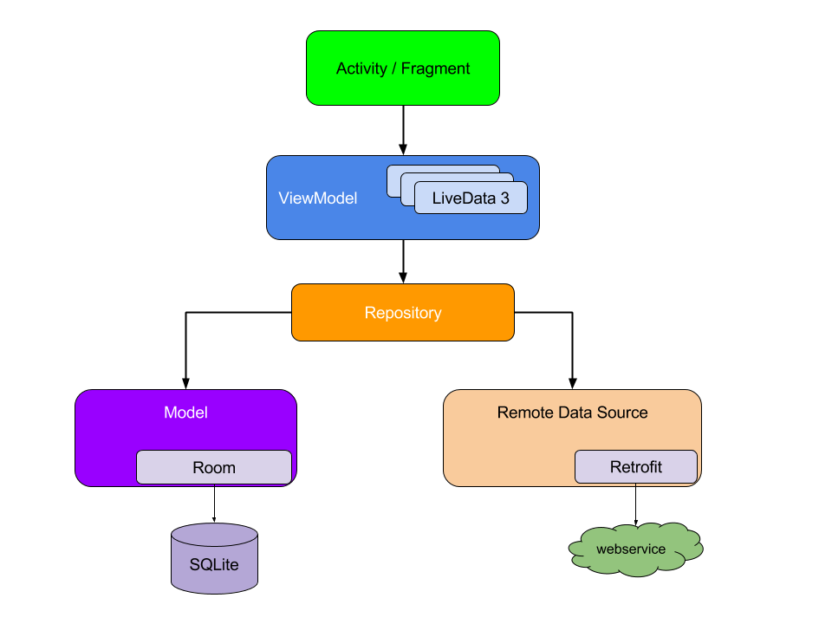

**Fig 3.1 Architecture Diagram**

**3.3 DEVELOPMENT ENVIRONMENT**

**3.3.1 HARWARE REQUIREMENTS**

The hardware requirements may serve as the basis for a contract for the system’s implementation. It should therefore be a complete and consistent specification of the entire system. It is generally used by software engineers as the starting point for the system design.

|  |  |
| --- | --- |
| **COMPONENTS** | **SPECIFICATION** |
| PROCESSOR | Intel Core i5 |
| RAM | 8 GB RAM |
| GPU | NVIDIA GeForce GTX 1650 |
| MONITOR | 15” COLOR |
| HARD DISK | 512 GB |
| PROCESSOR SPEED | MINIMUM 1.1 GHz |

**3.3.2 SOFTWARE REQUIREMENTS**

The software requirements document is the specifications of the system. It should include both a definition and a specification of requirements. It is a set of what the system should rather be doing than focus on how it should be done. The software requirements provide a basis for creating the software requirements specification. It is useful in estimating the cost, planning team activities, performing tasks, tracking the team, and tracking the team’s progress throughout the development activity.

**Android Studio** and **Arc** would all be required.

CHAPTER 4

**PROJECT DESCRIPTION**

**4.1 METHODOLOGY**

The methodology for developing WeatherCast involves a structured approach encompassing several key stages. Initially, extensive requirements analysis is conducted through user research and stakeholder discussions to define the scope of the application. This phase involves identifying essential features, understanding user personas, and establishing usability requirements to ensure the application meets the diverse needs of its target audience.

Following requirements analysis, a thorough technical research phase is undertaken to explore available weather APIs, GPS integration methods, and best practices in Kotlin programming. This involves evaluating various technologies and frameworks to determine the most suitable options for efficient development and seamless integration of essential functionalities.

Once the groundwork is laid, the development process kicks off with the creation of low-fidelity prototypes to visualize the user interface and navigation flow. These prototypes serve as a basis for gathering feedback from stakeholders, allowing for iterative refinement of design concepts to ensure optimal user experience.

Subsequently, the implementation phase commences, wherein WeatherCast is developed using Kotlin and Android Studio. This phase involves integrating real-time weather data from reliable sources through APIs, implementing GPS technology for location-based forecasts, and designing an intuitive user interface with customizable features. Throughout the implementation process, adherence to coding best practices and software design principles is maintained to ensure the application's scalability, maintainability, and performance.

Finally, rigorous testing is conducted to validate the functionality, reliability, and performance of WeatherCast across various devices and operating system versions. This includes functional testing to verify that all features work as intended, as well as usability testing to assess the application's ease of use and user satisfaction. Any identified issues or bugs are addressed promptly, and refinements are made iteratively based on user feedback and testing results, ensuring that WeatherCast meets the highest standards of quality and usability.

**4.2 MODULE DESCRIPTION**

The WeatherCast project comprises several interconnected modules, each serving a distinct purpose in the development and functionality of the application. The User Interface (UI) Module focuses on designing and implementing a visually appealing and intuitive interface adhering to Android's Material Design guidelines. The Data Integration Module manages the retrieval and processing of real-time weather data from external APIs like OpenWeatherMap, while the GPS Integration Module incorporates location-based functionality using Android's Location Services API. The Forecasting Module employs weather prediction algorithms to generate accurate forecasts, considering various meteorological factors. The Customization Module enables users to personalize their experience by selecting preferred units of measurement and setting weather alert preferences. The Testing Module ensures the reliability and performance of WeatherCast through rigorous testing procedures, including unit testing and usability testing.

CHAPTER 5

**RESULTS AND DISCUSSIONS**

**5.1 OUTPUT**

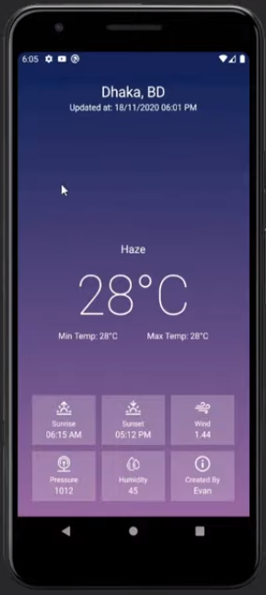

**Fig 5.1 Home Screen**

**5.2 RESULT**

The culmination of the WeatherCast project is a sophisticated and user-centric weather forecasting application for Android devices. With its intuitive user interface, users can seamlessly navigate through accurate weather forecasts, personalized to their preferences and location. Through integration with real-time weather data sources and GPS technology, WeatherCast delivers reliable forecasts, empowering users to make informed decisions and stay prepared for changing weather conditions. The application's customization options allow users to tailor their experience, further enhancing usability and satisfaction. Rigorous testing ensures the reliability and performance of WeatherCast across various devices and operating system versions. Ultimately, the result is a comprehensive and accessible weather application that meets the diverse needs of Android users, providing them with essential weather information at their fingertips.

CHAPTER 6

**CONCLUSION AND FUTURE ENHANCEMENTS**

**6.1 CONCLUSION**

In conclusion, WeatherCast represents a significant achievement in the realm of weather forecasting applications for Android devices. Through meticulous development and integration of advanced technologies, such as real-time data retrieval and GPS functionality, WeatherCast offers users a reliable and intuitive platform for accessing accurate weather forecasts. The application's user-centric design, customization options, and rigorous testing ensure a seamless and personalized experience for users, enhancing usability and satisfaction. WeatherCast's deployment to the Google Play Store signifies its readiness for widespread availability, catering to the diverse needs of Android users seeking reliable weather information. As WeatherCast continues to evolve and adapt to user feedback, it remains committed to providing unparalleled accuracy, usability, and convenience, empowering users to stay informed and prepared in the face of changing weather conditions.

**6.2 FUTURE ENHANCEMENTS**

1. **Enhanced Forecasting Algorithms**: Continuously improve the accuracy and reliability of weather forecasts by integrating advanced forecasting algorithms and machine learning techniques. This could involve analyzing historical weather data to refine prediction models and incorporating real-time atmospheric data from sensors and satellites.
2. **Severe Weather Alerts**: Implement proactive notifications for severe weather events such as storms, hurricanes, or heatwaves. Integrate with national weather services to provide timely alerts and safety recommendations to users in affected areas, helping them stay safe and informed.
3. **Localized Community Reporting**: Enable users to contribute localized weather observations and reports, creating a community-driven platform for sharing real-time weather updates. This could include features for users to submit photos, videos, and text updates, fostering a collaborative environment for weather monitoring.
4. **Smart Home Integration**: Integrate WeatherCast with smart home devices and platforms to provide seamless weather-related automation. For example, users could receive alerts to adjust thermostat settings based on upcoming temperature changes or receive notifications to close windows before rainstorms.
5. Accessibility Features: Enhance accessibility by implementing features such as voice-guided navigation, screen reader compatibility, and high-contrast UI options. Ensure that WeatherCast is accessible to users with visual or auditory impairments, promoting inclusivity and usability for all users.

**REFERENCES**

1. T. D. Keane and J. P. Evans, "Machine Learning Approaches to Forecasting," Journal of Climate, vol. 23, no. 22, pp. 6324–6345, 2010.
2. J. R. Taylor and S. S. Simonsen, "An Introduction to Error Analysis: The Study of Uncertainties in Physical Measurements," University Science Books, 1997.
3. A. Hardy and S. Sen, "Practical Android 10 Development: Mastering Kotlin Android Development with Google's Android 10 SDK," Apress, 2020.
4. M. L. Murphy, "Beginning Android Development with Kotlin: Master Android Programming with Kotlin," Apress, 2021.
5. Material Design Guidelines. [Online]. Available: https://material.io/design. [Accessed: May 20, 2024].